**ABSTRACT**

The airport database management system consists of different airports with their available terminals. It keeps track of all the flights, their routes, and Arrival and departure times. it also keeps track of the passenger and their booking information.

For each airport, there will be many terminals. each terminal is allowed to depart or arrive on the flights of some specific airlines. each airline might have many flights with different capacities.

Passengers, personal information such as Passenger name, city, mobile number, and email address should be available. passenger gets the passenger id upon registering into the system. Only the registered passenger are allowed to book the tickets.

The passenger can have the option to select the flight and route for booking the ticket. The arrivals and departures can also be tracked in the system for each flight.

The airline services will have the Origin country and each airline will have an owner. a specific terminal of the airport will be allocated to the airlines for departures and arrivals. for each airport, there will be different employees who work for only one airline.

**TABLE OF CONTENTS**

|  |  |  |
| --- | --- | --- |
| **CHAPTER No.** | **TITLE** | **PAGE No.** |
|  | **ABSTRACT** |  |
|  | **LIST OF FIGURES** |  |
|  | **LIST OF TABLES** |  |
| 1 | **INTRODUCTION OF THE PROJECT** |  |
| 2 | **PROJECT DESCRIPTION** |  |
| 3 | **LITERATURE SURVEY** |  |
| 4 | **ENTITIES** |  |
| 5 | **MAPPING ER DIAGRAM TO RELATIONAL SCHEMA** |  |
| 6 | **ER/EER DIAGRAM** |  |
| 7 | **NORMALIZATION RULES ON DATABASE** |  |
| 8 | **NORMALIZED RELATIONAL SCHEMA** |  |
| 9 | **RELATIONAL ALGEBRAIC EXPRESSIONS** |  |
| 10 | **CONCLUSION** |  |

**LIST OF FIGURES**

|  |  |  |
| --- | --- | --- |
| **Sl.No.** | **Figure Name** | **Page No.** |
| 1 | Applied SLR method |  |
| 2 | Passenger Booking Ticket |  |
| 3 | Airport Management System ER diagram |  |
| 4 | Normalization relational schema |  |

**LIST OF TABLES**

|  |  |  |
| --- | --- | --- |
| **Sl.No.** | **Name** | **Page No.** |
| 1 | Airline codes |  |
| 2 | Airport names |  |
| 3 | ER diagram relationships |  |
| 4 | Binary relationships |  |

**CHAPTER 1**

**INTRODUCTION OF THE PROJECT**

* 1. **INTRODUCTION**

This is an International Airport Database project consisting of developing entities and their respective attributes. This approach also includes writing and applying queries as required. After forming initial Entities with their attributes, we develop ER diagram for given entities in further phases.

Scheduling flights, managing different service-provided Airplanes with respect to their terminals, Bookings of flights, and details of passengers are the main aspects that are covered under this project. This database can handle different requests and provides an output based on the above entities. The results from this database are used by airport authorities for better decision-making.

Airline and airport management is the administration of airports and airlines. It includes the activities of setting the strategy of airports to gather and provide information on airline commercial and operational priorities. It covers a broad overview of airline management.

It is also studied as a branch of study that teaches the management of airports and airlines. This provides a broad overview of the airline industry and creates awareness of the underlying marketing, financial, operational, and other factors influencing airline management. This study provides information on airline commercial and operational priorities, along with teaching the key characteristics of aircraft selection and the impact of airport decision-making.

* 1. **PROBLEM STATEMENT**

The main objective of the project is to learn and implement a real-time application on a database for an airport database management system. The project concentrates on bookings and tracking flights. This Database will be a great solution for many functionalities in Airport. The goal of the Airport Master Plan is to provide the framework needed to guide future airport development that will cost-effectively satisfy aviation demand while considering potential environmental and socioeconomic issues.

* 1. **AIM OF THE PROJECT**

The aim of the project is to learn and implement a real-time application on a database for an airport database management system.

**1.3 PROJECT DOMAIN**

A database management system (DBMS) is a software tool that enables users to manage a database easily. It allows users to access and interact with the underlying data in the database. These actions can range from simply querying data to defining database schemas that fundamentally affect the database structure.

* 1. **METHODOLOGY**

This section describes the Systematic Literature Review (SLR) method used for conducting this review. We have also considered some recent studies with SLR method to apply in our work. SLR uses systematic methods to define research question, conduct literature search, screen the findings, extract the data from the selected findings, analyse and synthesize the findings qualitatively or quantitatively.

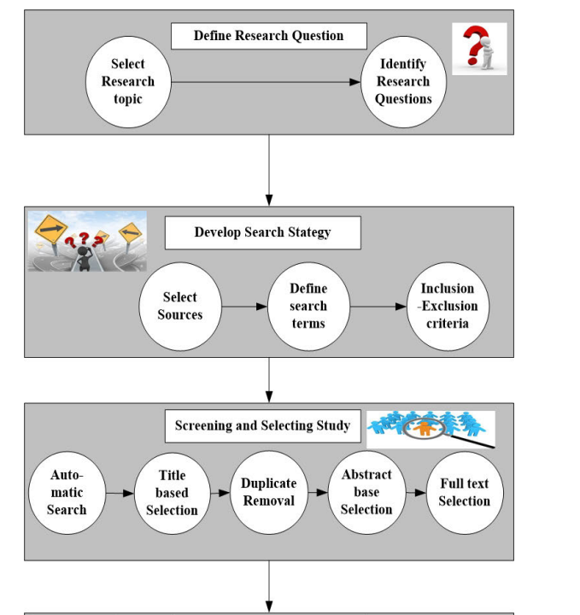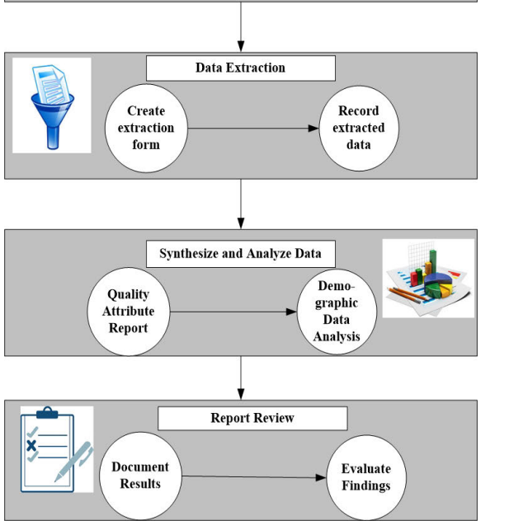

Fig No:1.1 Applied SLR method

**CHAPTER 2**

**PROJECT DESCRIPTION**

Domain: Airport Management System

**2.1 Requirements of the system**

The system is based on airport management. Airport management system primarily deals with the management of airports, airlines and passengers. The system provides a broad overview of underlying operational factors that influence airport management. The database system has the data of all commercial service airports. An airport is located in a city. All International airlines operating in various countries across the world have their offices located in all major cities and airports they cover. Hence, an airport may have many airline offices. Every airline is identified uniquely by an airline code. The airline code is a two-letter airline designator. The airline also has a three-digit code which is printed on an air ticket.

Airline codes

|  |  |  |
| --- | --- | --- |
| Airline Name | IATA Airline code/IATA Designator | 3-DIGIT CODE |
| American Airlines | AA | 1 |
| Air India Limited | AI | 98 |
| Lufthansa | LH | 220 |
| British Airways | BA | 125 |
| Qatar Airways | QR | 157 |
| Jet Airways | 9W | 589 |
| Emirates | EK | 176 |
| Ethiad Airways | EY | 607 |

Airline companies serve flights. Every flight is uniquely identified by a flight code. A flight code is a combination of an airline code and a four-digit number. o Flight takes off from one airport and lands at another airport. Therefore, the most important aspect of a flight is, its source and destination. Source and destination airports are identified using an airport's IATA code. International Air Transport Airport code is simply a location identifier. IATA code is a three-letter code designating many airports across the world. These codes are prominently displayed on baggage tags and printed on an air tickets.

|  |  |
| --- | --- |
| Airport Name | IATA Airport code |
| Louisville International Airport | SDF |
| Chandigarh International Airport | IXC |
| Dallas/Fort Worth International Airport | DFW |
| Indira Gandhi International Airport | DEL |
| Chhatrapati Shivaji International Airport | BOM |
| San Francisco International Airport | SFO |
| Frankfurt Airport | FRA |
| George Bush Intercontinental Airport | IAH |
| John F. Kennedy International Airport | JFK |
| Tampa International Airport | TPA |

* Flight serves passengers. Flight carries passengers from source to destination.
* A passenger is uniquely identified by a passenger id and a passport number.
* Every passenger has details such as name, address, age, sex, phone.
* For a passenger to travel by a flight, he needs a ticket. A ticket or air ticket is used to confirm that an individual has reserved a seat on a flight. With the ticket, a passenger is allowed to board the flight.

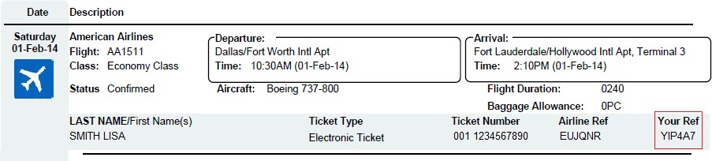

Fig 2.1: Passenger Booking Ticket

**2.2 Assumptions**

We are not considering privately managed airports. We are only considering publicly owned airports.

Several Categories of airports:

1. Commercial Service Airport

These are publicly owned airports that serve aircraft which provide scheduled passenger service.

1. Cargo Service airports

These airports serve aircraft carrying cargo only

* The system is designed only for international flights.
* A city has at most one international airport.
* For Connecting flights, flight and airline remains the same at layover stops
* There are different types of jobs available at the airport. For simplicity, our system considers a few jobs only.

**2.3 FEASIBILITY STUDY**

A Feasibility study is carried out to check the viability of the project and to analyze the strengths and weaknesses of the proposed system. Theapplication of usage of mask in crowd areas must be evaluated. The feasibility study is carried out in three forms.

• Economic Feasibility

• Technical Feasibility

• Social Feasibility

**2.3.1 ECONOMIC FEASIBILITY**

The proposed system does not require any high cost equipment. This project can be developed within the available software.

**2.3.2 TECHNICAL Feasibility**

The proposed system is completely a Machine learning model. The main tools used in this project are Anaconda prompt, Visual studio, Kaggledata sets, Jupyter Notebook And the language used to execute theprocess in Python. The above mentioned tools are available for free and technical skills required to use this tools are practicable. From this we can conclude that the project is technically feasible.

**2.3.3 SOCIAL FEASIBILITY**

Social feasibility is a determination of whether project will be acceptable or not. our project is Eco-friendly for society and there is no social issues. our project must not threatened by the system instead must accept it as a necessity. since our project is applicable for every individuals in the society to take care about the society and environment. The level of the acceptance of System is very high and it depends on the methods deployed in the system. our system is highly familiar with the society.

**2.4 SYSTEM SPECIFICATION**

**2.4.1 HARDWARE SPECIFICATION**

* Processor - Intel i5-8250 CPU @1.60GHz 1.80GHz
* 512 GB SSD
* NVIDIA GEFORCE RTX
* CPU QUAD CORES

**CHAPTER 3**

**LITERATURE SURVEY**

**M. Kadoguchi, S. Hayashi, M. Hashimoto, and A. Otsuka, ' 'F*ploring the dark web for cyber threat intelligence using machine leaning," in Proc. IEEE Int. conf. Intell. Secun Informat. (ISI), Jul. 2019, pp. 200-202, doi:10.1109/1s1.2019.8823360.**

**Concept and Theme of the paper**: Using ML and doc2vec Extraction Of forums that have intelligence information and identify traits

**Methods:** MLP, a multi-layer perceptron technique, is used by machine learning.

**Result:** Classification receives only critical posts from the forums and generates the ranking of the forum based on the number of critical posts with the accuracy of 79.4%.

**M. Schafer, M. Fuchs, M. Strohmeier, M. Engel, M. Liechti, and V. Lenders, "Black Widow: Monitoring the dark web for cyber security information," in Pmc. 1 lth Int. Conf. Cyber Conflict (CyCon), May 2019, pp. 1-21, doi: 10.23919/CYCON.2019.8756845.**

**Concept and Theme of the paper**: Using Black-widow, a survey is conducted on seven different services across three other languages

**Methods:**

* node.js Chrome puppeteer crawler. Is headless browser used as a Crawler.
* Extractor in Scala is used.

**Result:** Blackwidow automatically found relationships between threads and forums

**Y. Yang, L. Yang, M. Yang, H. Yu, G. Zhu, Z. Chen, and L. Chen, "Dark web forum correlation analysis research," in Proc. IEEE 8th Joint Int. Inf Technol. Ani/ Intell. Conf.**

**(ITAIC), May 2019, pp. 1216—1220, doi: 10.1109/1TAIC.2019.8785760.**

**Concept and Theme of the paper**: The idea is to resolves topic-based key members

Issue

**Methods:**

* Python + onionscaon used as a data crawler
* Filtering through Boolean KMP algorithm
* logic retrieval model

**Result:** Network diagram and histogram visualization of threats. Forum requests are presented in histograms and diagrams.

**N. Tavabi, N. Bartley, A. Abeliuk, S. Soni, E. Ferrara, and K. Leman, "Characterizing activity on the deep and dark web," 2019, arXiv:1903.00156.**

**Concept and Theme of the paper**: developed a visual dark web forum post sociation analysis system to display the relationship graphically.

**Methods:**

* Web crawling through python+onionscan
* FudanNLP for pre-processing
* Mahout's naive Bayesian for text classification Kanopy+mean algorithm for text clustering

**Result:** Clusters were representing different malicious activities discussing in forums.

**Chapter 4**

**ENTITIES**

|  |  |  |
| --- | --- | --- |
| CNAME | STATE | COUNTRY |

CITY

|  |  |  |
| --- | --- | --- |
| AP_NAME | STATE | COUNTRY |

AIRPORT

AIRLINE

|  |  |  |
| --- | --- | --- |
| AIRLINEID | AL_NAME | THREE_DIGIT_CODE |

FLIGHT

|  |  |  |  |  |  |  |  |
| --- | --- | --- | --- | --- | --- | --- | --- |
| FLIGHT_CODE | SOURCE | DESTINATION | ARRIVAL | DEPARTURE | STATUS | DURATION | FLIGHTTYP |
| LAYOVER_TIME | NO_OF_STOPS |  | | | | | |

PASSENGER

|  |  |  |  |  |  |  |  |  |
| --- | --- | --- | --- | --- | --- | --- | --- | --- |
| PID | PASSPORT_NO | FNAME | M | LNAME | ADDRESS | PHONE | AGE | SEX |

TICKET

|  |  |  |  |  |  |  |
| --- | --- | --- | --- | --- | --- | --- |
| TICKET_NUMBER | SOURCE | DESTINATION | DATE_OF_TRAVEL | SEATNO | CLASS | PRICE |

EMPLOYEE

|  |  |  |  |  |  |  |  |  |  |
| --- | --- | --- | --- | --- | --- | --- | --- | --- | --- |
| SSN | FNAME | M | LNAME | ADDRESS | PHONE | AGE | SEX | JOBTYPE | SALARY |

**Chapter 5**

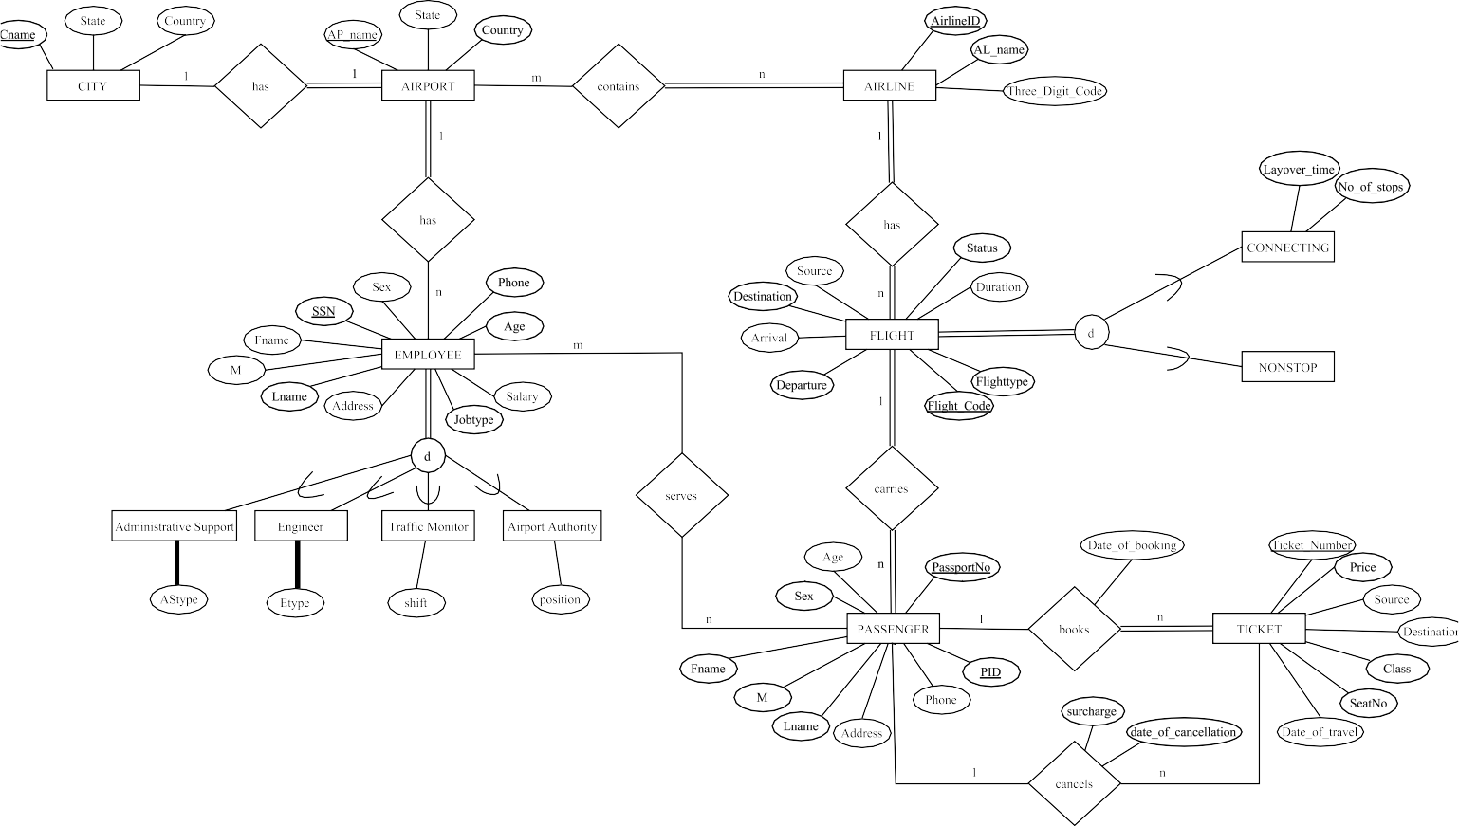**MAPPING ER DIAGRAM TO RELATIONAL SCHEMA**

Fig.No:4.1 Airport Management System ER diagram

**Chapter 6**

**ER/EER DIAGRAM**

ER diagram contains following relationships

|  |  |  |  |
| --- | --- | --- | --- |
| Entity 1 | Name of the Relationship | Entity 2 | Cardinality |
| City | has | Airport | 1:1 |
| Airport | contains | Airline | m : n |
| Airport | has | Employee | 1 : n |
| Airline | has | Flight | 1 : n |
| Flight | carries | Passengers | 1 : n |
| Employee | serves | Passengers | m : n |
| Passenger | books | Ticket | 1 : n |
| Passenger | cancels | Ticket | 1 : n |

|  |  |
| --- | --- |
| Type of the binary relationship | Relationships in the system |
| one-to-one | (1 A city has only one airport. |
| one-to-many | 1. An airline has multiple flights, that is many flights belong to the same airline company. 2. A flight carries many passengers. 3. A passenger can book one or more tickets. 4. A passenger can cancel one or more tickets. |
| many-to-many | All International airlines operating through various countries across the world have their offices located in all major cities and airports they cover. Hence, an  airport may have many airline offices. |

**Chapter 7**

# **NORMALIZATION RULES ON DATABASE**

|  |  |
| --- | --- |
| FUNCTIONAL DEPENDECIES |  |
| PASSPORTNO -> FNAME, M, LNAME, ADDRESS, PHONE, AGE, SEX | Violates 2NF |
| PID -> FLIGHT_CODE | Violates 2NF |
| DATE_OF_BOOKING, SOURCE, DESTINATION, CLASS -> PRICE | Violates 3NF |
| DATE_OF_CANCELLATION -> SURCHARGE | Violates 3NF |
| JOBTYPE -> SALARY | Violates 3NF |

Normalizing into 3NF

CITY (CNAME, STATE, COUNTRY)

AIRPORT (AP_NAME, STATE, COUNTRY, CNAME)

AIRLINE (AIRLINEID, AL_NAME, THREE_DIGIT_CODE)

CONTAINS (AIRLINEID, AP_NAME)

FLIGHT (FLIGHT_CODE, SOURCE, DESTINATION, ARRIVAL, DEPARTURE, STATUS, DURATION, FLIGHTTYPE, LAYOVER_TIME, NO_OF_STOPS, AIRLINEID)

PASSENGER1 (PID, PASSPORTNO)

PASSENGER2(PASSPORTNO, FNAME, M, LNAME, ADDRESS, PHONE, AGE, SEX)

PASSENGER3 (PID, FLIGHT_CODE)

TICKET1 (TICKET_NUMBER, SOURCE, DESTINATION, DATE_OF_BOOKING, DATE_OF_TRAVEL, SEATNO, CLASS, DATE_OF_CANCELLATION, PID, PASSPORTNO)

TICKET2 (DATE_OF_BOOKING, SOURCE, DESTINATION, CLASS, PRICE)

TICKET3 (DATE_OF_CANCELLATION, SURCHARGE)

EMPLOYEE1 (SSN, FNAME, M, LNAME, ADDRESS, PHONE, AGE, SEX, JOBTYPE, ASTYPE, ETYPE, SHIFT, POSITION, AP_NAME)

EMPLOYEE2(JOBTYPE, SALARY)

SERVES (SSN, PID, PASSPORTNO)

**Chapter 8**

# **NORMALISED RELATIONAL SCHEMA**

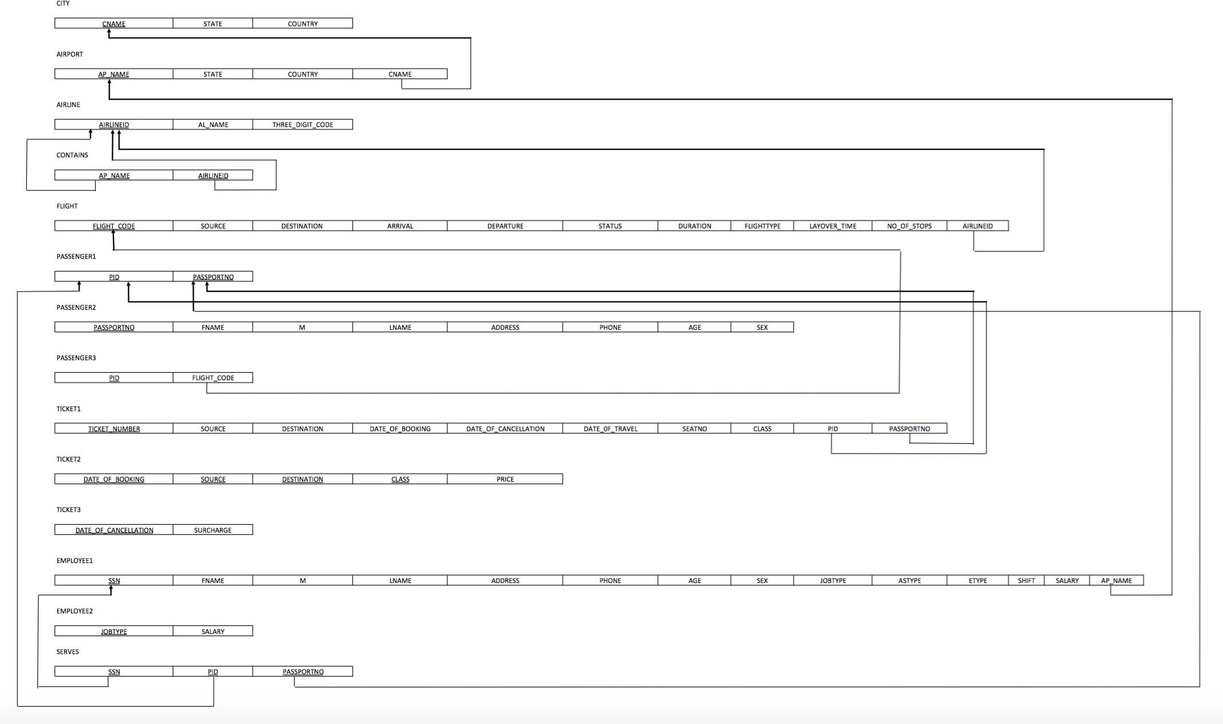

Fig.No:7.1 Normalization relational schema

**Chapter 9**

**Relational algebraic expressions**

* **List out the names and Mobile Number of the Passenger who are traveling to India.**

[Greek letter pi](http://www.databasteknik.se/webbkursen/relalg-lecture/huge-pi.gif) p.Name, p.mobile([[Greek letter sigma](http://www.databasteknik.se/webbkursen/relalg-lecture/huge-sigma.gif) p.Destination = "India"[Greek letter rho](http://www.databasteknik.se/webbkursen/relalg-lecture/huge-rho.gif)c(Passenger)] p.Passenger_Id= p.passenger_Id [[Greek letter rho](http://www.databasteknik.se/webbkursen/relalg-lecture/huge-rho.gif)p(Destination)])

* **List out the Flight details whose capacity is more than 1000.**

[[Greek letter sigma](http://www.databasteknik.se/webbkursen/relalg-lecture/huge-sigma.gif) f.Capacity> 1000([Greek letter rho](http://www.databasteknik.se/webbkursen/relalg-lecture/huge-rho.gif)s(Flight)] [Join symbol](http://www.databasteknik.se/webbkursen/relalg-lecture/huge-join.gif) f.flight_Id= f.flight_Id [[Greek letter rho](http://www.databasteknik.se/webbkursen/relalg-lecture/huge-rho.gif)f(capacity)]

* **List the staff details who works in Newyork Airport and designation is chef.**

[[Greek letter sigma](http://www.databasteknik.se/webbkursen/relalg-lecture/huge-sigma.gif) d.Airport = “Newyork” ^ s.designation =”Chef”[Greek letter rho](http://www.databasteknik.se/webbkursen/relalg-lecture/huge-rho.gif)s(staff)] [Join symbol](http://www.databasteknik.se/webbkursen/relalg-lecture/huge-join.gif) s.airport_id = s.airport_id [[Greek letter rho](http://www.databasteknik.se/webbkursen/relalg-lecture/huge-rho.gif)d(designation)]

* **Display the number of food items and their names in each category of food.**

f.flight_id, f.flight_name Fcount(*) ([[Greek letter rho](http://www.databasteknik.se/webbkursen/relalg-lecture/huge-rho.gif)i(ticket)] [Join symbol](http://www.databasteknik.se/webbkursen/relalg-lecture/huge-join.gif) f.flight_id = f.flight_id [[Greek letter rho](http://www.databasteknik.se/webbkursen/relalg-lecture/huge-rho.gif)f(flight)])

* **List out the names of the passengers who booked more than 5 tickets.**

[Greek letter pi](http://www.databasteknik.se/webbkursen/relalg-lecture/huge-pi.gif) p.name(([[Greek letter sigma](http://www.databasteknik.se/webbkursen/relalg-lecture/huge-sigma.gif)p.Quantity > 5 ^ i.Name = “Ticket” ([Greek letter rho](http://www.databasteknik.se/webbkursen/relalg-lecture/huge-rho.gif)c(Passenger))] [Join symbol](http://www.databasteknik.se/webbkursen/relalg-lecture/huge-join.gif)p..passanger_ID =p.passanger_ID [[Greek letter rho](http://www.databasteknik.se/webbkursen/relalg-lecture/huge-rho.gif)o(bookings)]) [Join symbol](http://www.databasteknik.se/webbkursen/relalg-lecture/huge-join.gif)b.booking_id = b..ticket_id [[Greek letter rho](http://www.databasteknik.se/webbkursen/relalg-lecture/huge-rho.gif)i(Ticket)])

* **List out the names of the passengers who is travelling from Bridgeport and to California.**

[Greek letter pi](http://www.databasteknik.se/webbkursen/relalg-lecture/huge-pi.gif) p.name(([[Greek letter sigma](http://www.databasteknik.se/webbkursen/relalg-lecture/huge-sigma.gif)c.city = “Bridgeport” ^ c.Name = “California” ^ T.date = “11/12/2016” ([Greek letter rho](http://www.databasteknik.se/webbkursen/relalg-lecture/huge-rho.gif)p(Passanger))] [Join symbol](http://www.databasteknik.se/webbkursen/relalg-lecture/huge-join.gif)p.passanger_ID = p.passanger_ID [[Greek letter rho](http://www.databasteknik.se/webbkursen/relalg-lecture/huge-rho.gif)t(Ticket)]) [Join symbol](http://www.databasteknik.se/webbkursen/relalg-lecture/huge-join.gif)t.ticket_id = t.ticket_id [[Greek letter rho](http://www.databasteknik.se/webbkursen/relalg-lecture/huge-rho.gif)t(ticket)])

**Chapter 10**

**CONCLUSION**

Before starting the design of the airport, it's vital to establish the main objectives of the company, study the different aspects that can affect us and, finally, define the strategy that would allow us to obtain these objectives defined.

It's very important to check continuously the current legislation in order to guarantee a minimum level of security or safety and avoid possible penalties.

We have to take into account new technologies because these can improve the efficiency of airport operations and the sustainability of the environment (reduction of pollutants, disposable materials...).

The efficiency and availability of the airport don’t depend only on the usage, these factors can be affected from the initial project. For this reason, we should do a study of all the elements that are involved in our project design in order to increase the lifespan of the facilities and reduce the shutdowns, inoperative times and costs.

It is very important to carry out a feasibility study to know it the opportunity for the firm to succeed in the business is high and, also, we have to pay attention to the possible risks that may affect our profits in order to establish key solutions to reduce the negative consequences of that.

Teamwork, commitment and communication between workers are essential to perform correctly the different tasks.

Also, an emergency plan is essential because we have to know how to respond in the best possible way to different problems at the airport.

We have to perform the maintenance of the different facilities because it will reduce the inoperability of the airport and the costs in long-term.

In the facilities design, it's important to choose appropriate materials and dimensions from the point of view of cost and operation. In addition, the design has to comply with corresponding regulations